# Consider this model output from *brms*(). It estimates the regression that miles per gallon changes across a car’s horsepower (i.e., mpg ~ hp_c). The horsepower data are centered before analysis (hence “hp_c”). After centering the value of hp_c ranges from -94 to +188.

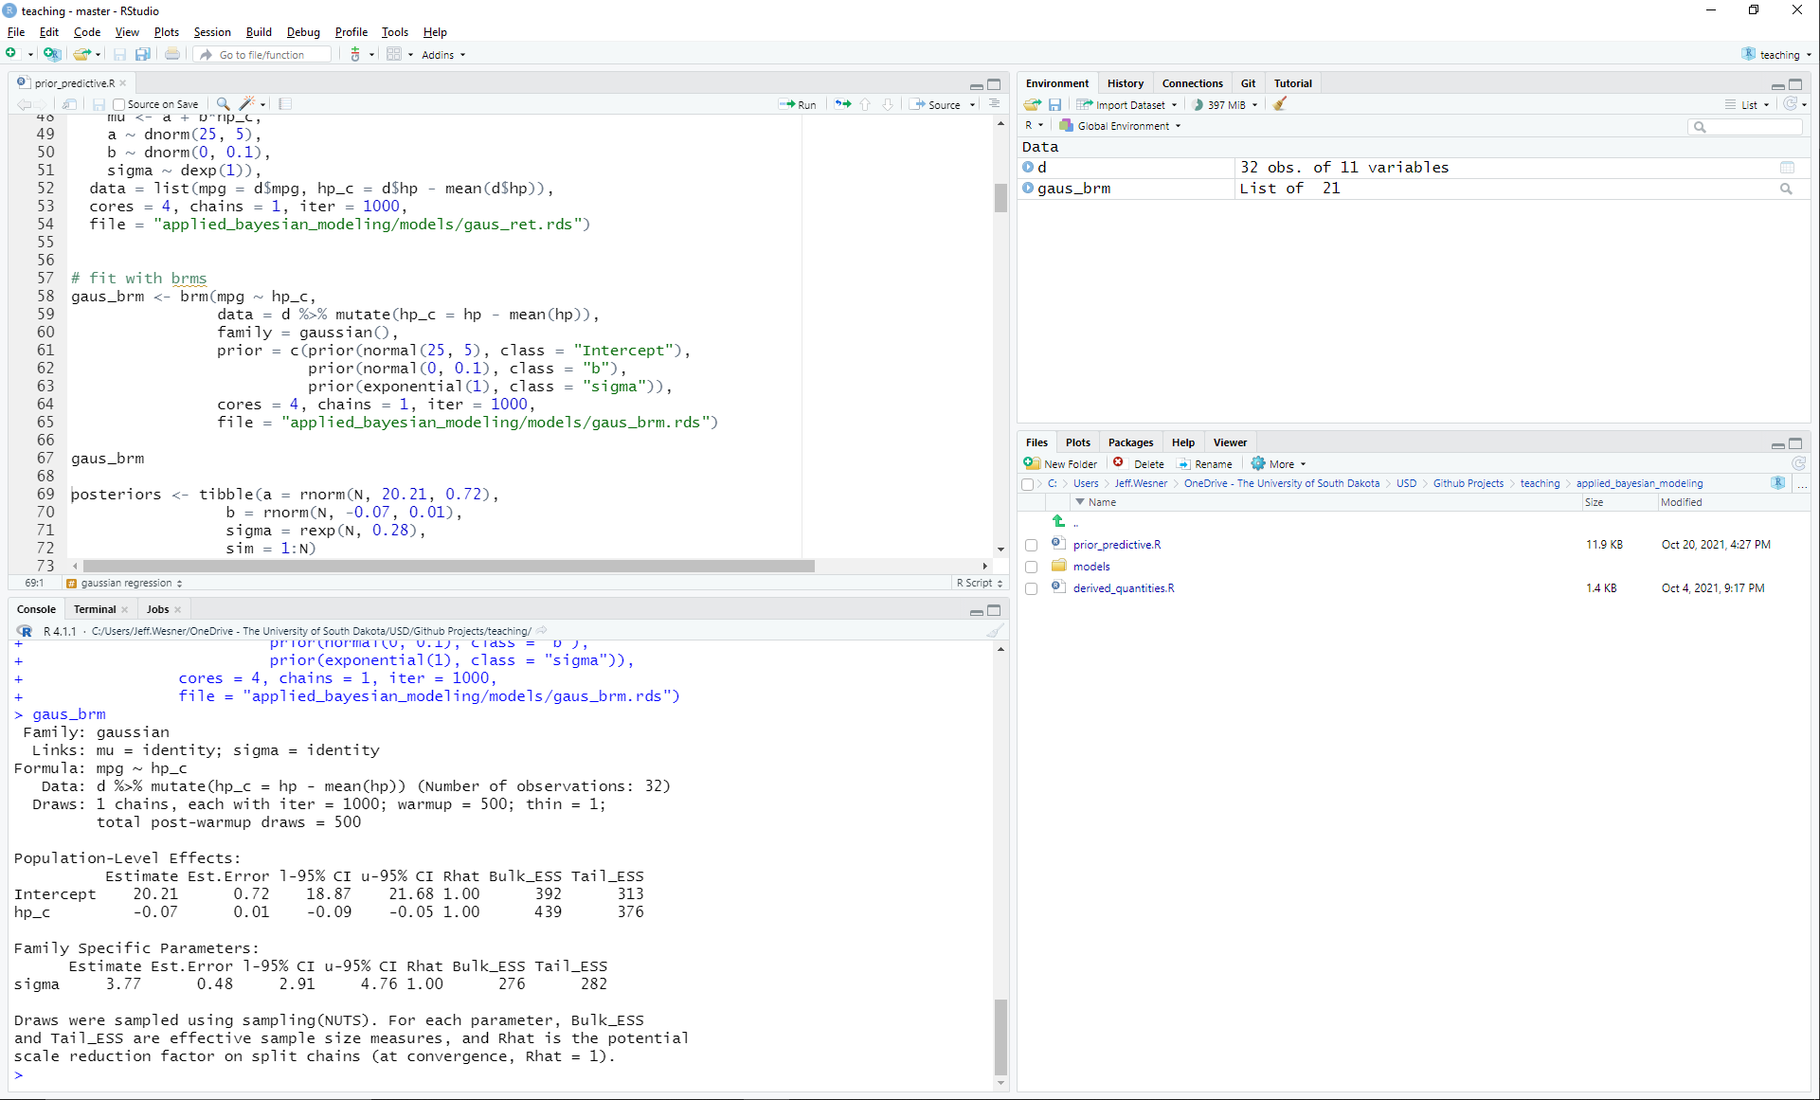

What is the posterior prediction of mpg for an average car?

What is the posterior prediction of mpg of a car with hp_c = 155?

What is the posterior prediction of mpg of a car with hp_c = -105?

Using R, simulate the mpg of 10 average cars from the posterior distribution.

# Consider this model output from *brms*(). It estimates the regression that Blue Sucker lengths (in mm) vary across Rivers. There are six rivers: Big Sioux, Colorado, Missouri, James, Red, and Wabash. It has a Poisson likelihood with a log link.

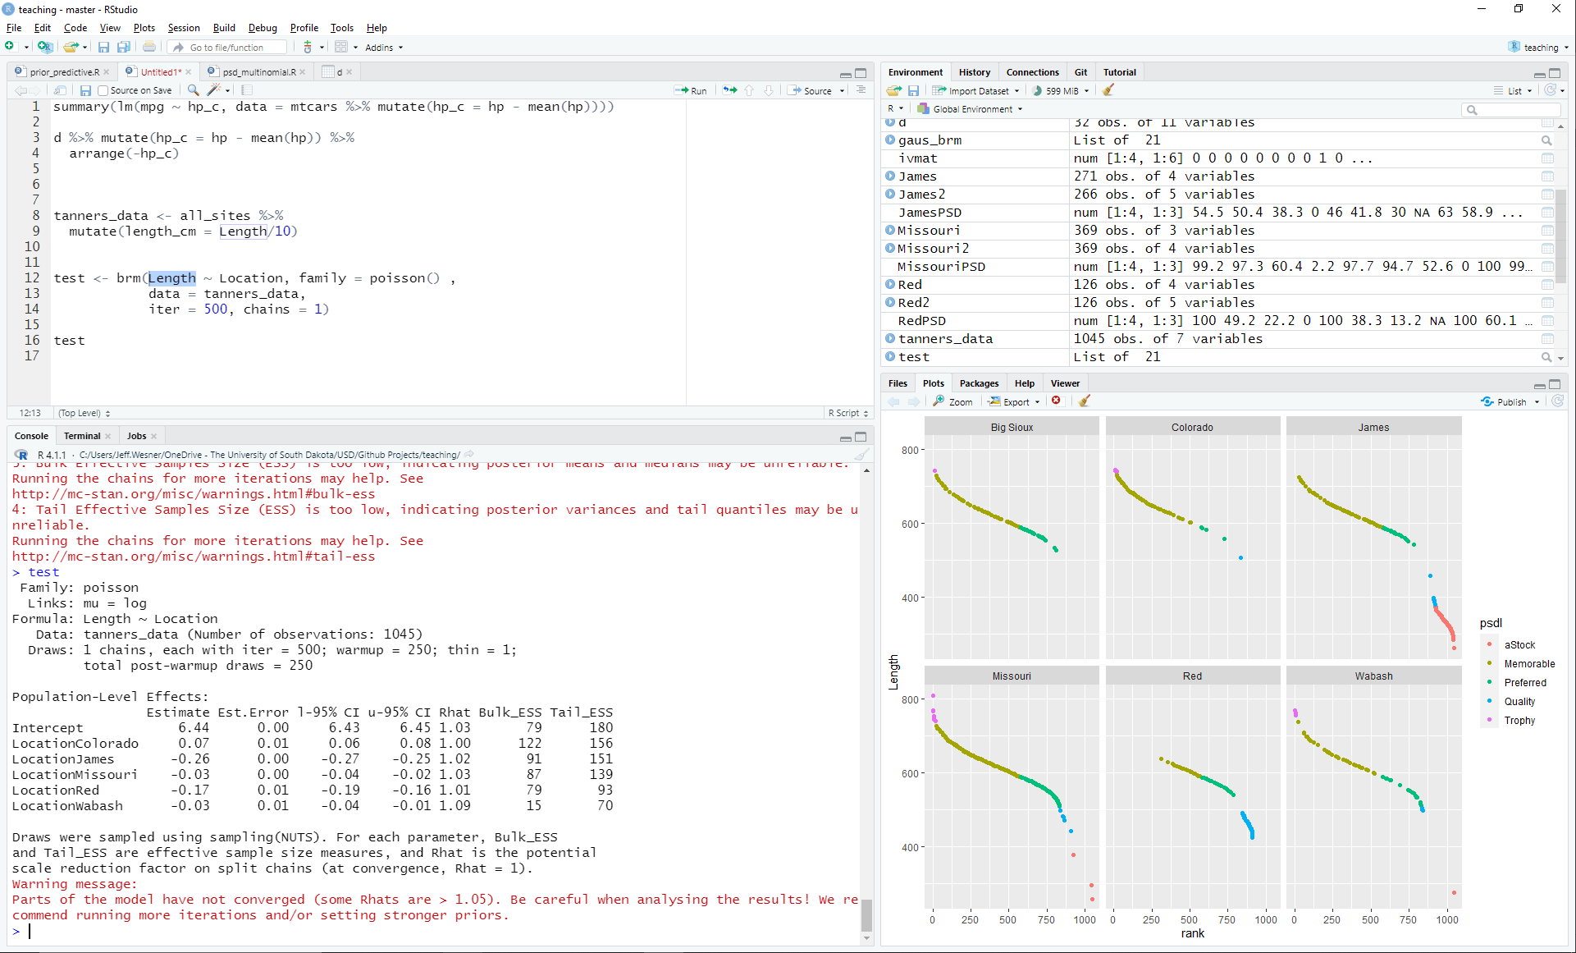

What is the posterior prediction of length for an average fish from the Colorado River?

What is the posterior prediction of length for an average fish from the Big Sioux River?

Using R, simulate the length of 100 fish from the Red River.